**Practical No. 15 and 16: Develop program for implementation of Wrapper Class to convert primitive into object and object into primitive.**

1. **Practical Significance:**

Wrapper classes are used to convert primitive data type into an object. The primitive data type are not objects. They are predefined in the language itself. Students should be able to use different wrapper classes and their methods.

1. **Relevant Course Outcome:**

Develop programs using Object Oriented methodology in Java.

1. **Practical Outcome:**

Develop program for implementation of Wrapper Class to convert primitive into object.

1. **Minimum Theoretical Background:**

|  |  |  |
| --- | --- | --- |
| **Sr.**  **No.** | **Method** | **Purpose** |
| 1. | purseInt(s) | Returns a signed decimal integer value equivalent to string s. |
| 2. | tostring() | Returns a new String object representing the integer i. |
| 3. | byteValue() | Returns the value of this Integer as a byte. |
| 4. | doubleValue() | Returns the value of this Integer as a double. |
| 5. | floatValue() | Returns the value of this Integer as a float. |
| 6. | intValue() | Returns the value of this Integer as an int. |
| 7. | shortValue() | Returns the value of this Integer as a short. |
| 8. | longValue() | Returns the value of this Integer as a long. |
| 9. | int compareTo(int i) | Compare the numerical value of the invoking object with that of i. Returns 0 if values are equal. Returns a negative value if the invoking objects has a lower value. Returns a positive value if the invoking object has a greater value. |
| 10. | static int compare(int num1, int num2) | Compare the values of num1 and num2. Returns 0 if the values are equal. Returns a negative value if num1 is less than num2. Returns a positive value if num1 is greater than num2. |
| 11. | boolean equlas(Object intObj) | Returns true if the invoking Integer object is equivalent to intObj. Otherwise, it returns false. |

1. **Program Code:**

import java.util.*;

public class WrapperClassMethod

{

public static void main(String[] args)

{

int a = 17;

Integer x = new Integer(a);

System.out.println("Value of x is :" + x);

System.out.println("toString(a) = " + Integer.toString(a)); //toString

System.out.println("valueOf(a) = " + x); //valueOf

System.out.println("parseInt(a) = " + x); //parseInt

byte b = x.byteValue(); //byteValue

System.out.println("byte b = " + b);

double d = x.doubleValue(); //doubleValue

System.out.println("double d = " + d);

float f = x.floatValue(); //floatValue

System.out.println("float f = " + f);

int i = x.intValue(); //intValue

System.out.println("int i = " + i);

short s = x.shortValue(); //shortValue

System.out.println("short s = " + i);

long l = x.longValue(); //longValue

System.out.println("long l = " + l);

Integer y = new Integer(17);

System.out.println("Value of y is :" + y);

Integer z = new Integer(24);

System.out.println("Value of z is :" + z);

System.out.println("y compareTo with z : "+ y.compareTo(z)); //compareTo

System.out.println("y compareTo with x : "+ y.compareTo(x)); //compareTo

Integer t = new Integer(6);

System.out.println("Value of t is :" + t);

Integer c = new Integer(3);

System.out.println("Value of c is :" + c);

Integer m = new Integer(6);

System.out.println("Value of m is :" + m);

System.out.println("t compare with c : "+ t.compareTo(c)); //compare

System.out.println("t compareTo with m : "+ t.compareTo(m)); //compare

System.out.println("Comparing using equals t and c: " + t.equals(c)); //equals

System.out.println("Comparing using equals t and m: " + t.equals(m)); //equals

}

}

1. **Result:**

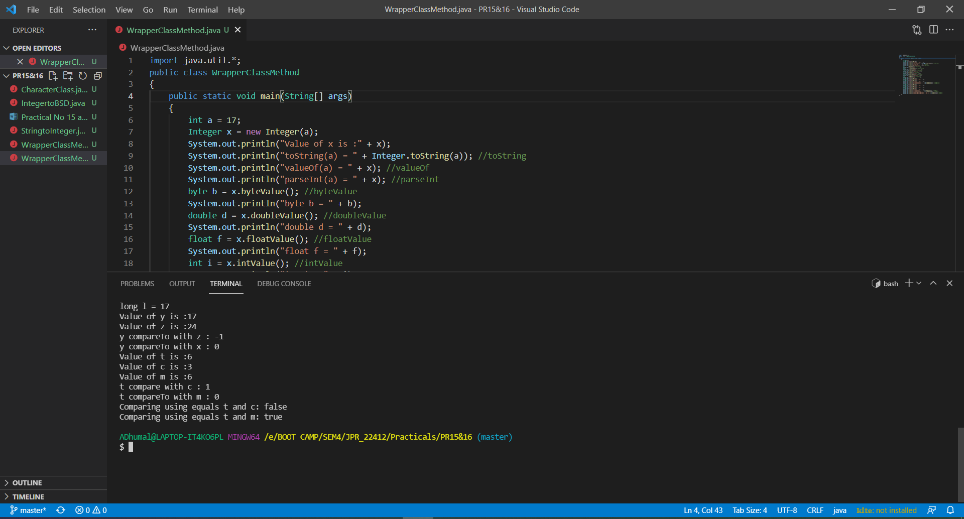

1. **Practical Related Questions:**
2. **Write a different ways to create object of the any primitive data type.**
3. Java new Operator.
4. Java Class. newInstance() method.
5. Java newInstance() method of constructor.
6. Java Object. clone() method.
7. Java Object Serialization and Deserialization
8. **Write a methods of Number class to convert object into primitive data type.**
9. intValue()
10. byteValue()
11. doubleValue()
12. shortValue()
13. floatValue()
14. longValue()
15. **List all wrapper class in java.**
16. Integer
17. Byte
18. Double
19. Short
20. Float
21. Long
22. Character
23. Boolean
24. **Exercise:**
25. **Write a program to convert String value into Integer Wrapper class object.**

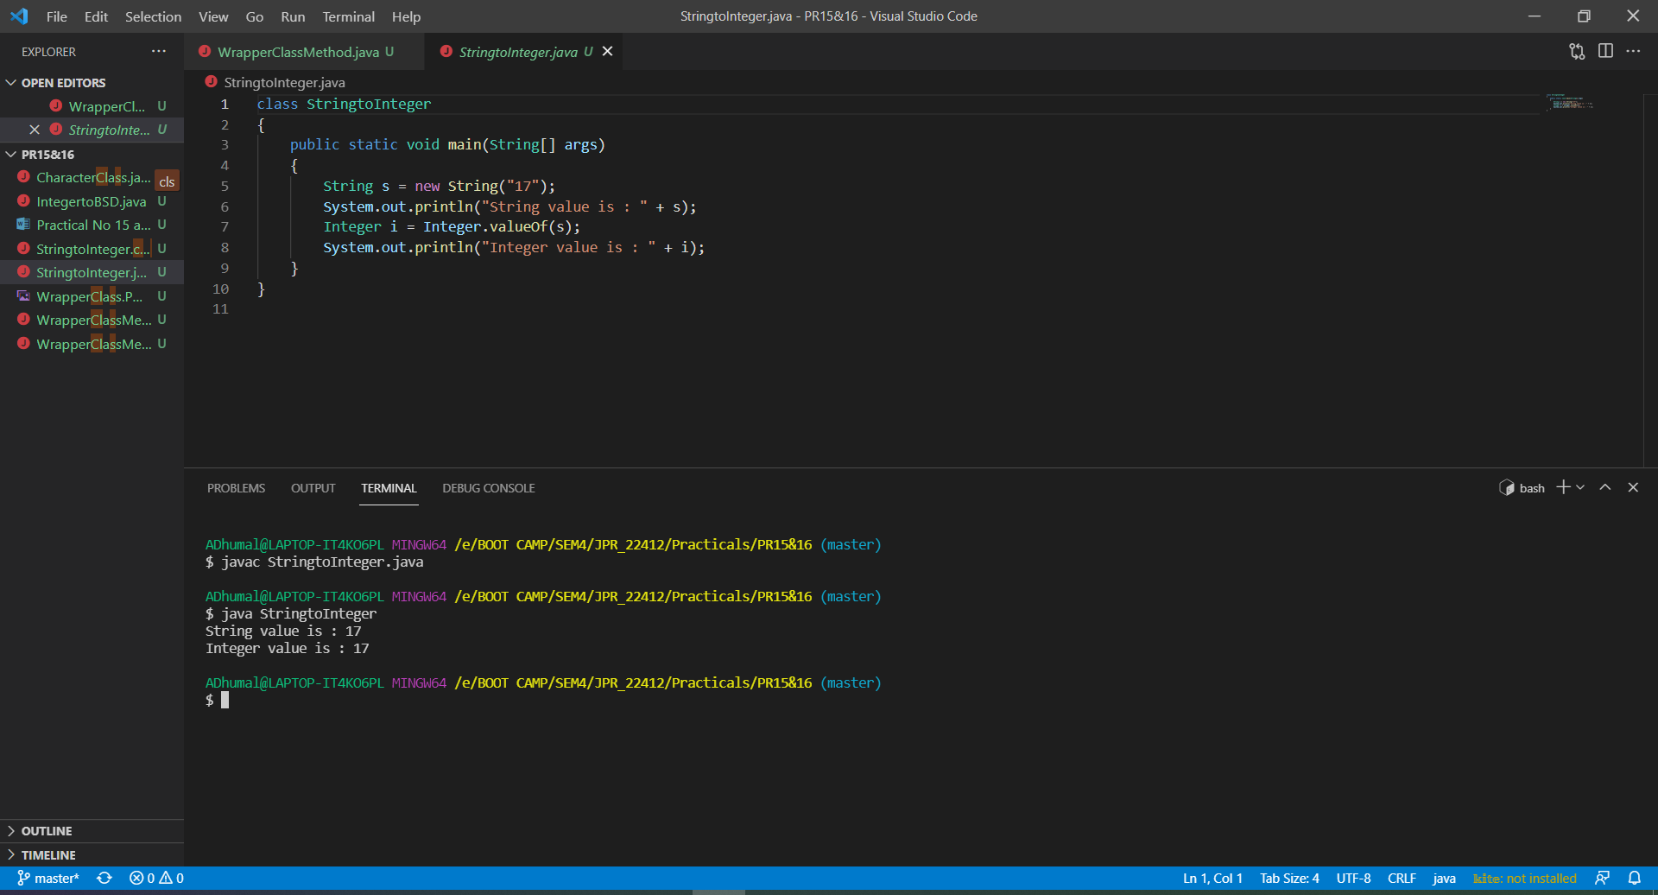

1. **Write a program to make use of Character Wrapper class methods.**

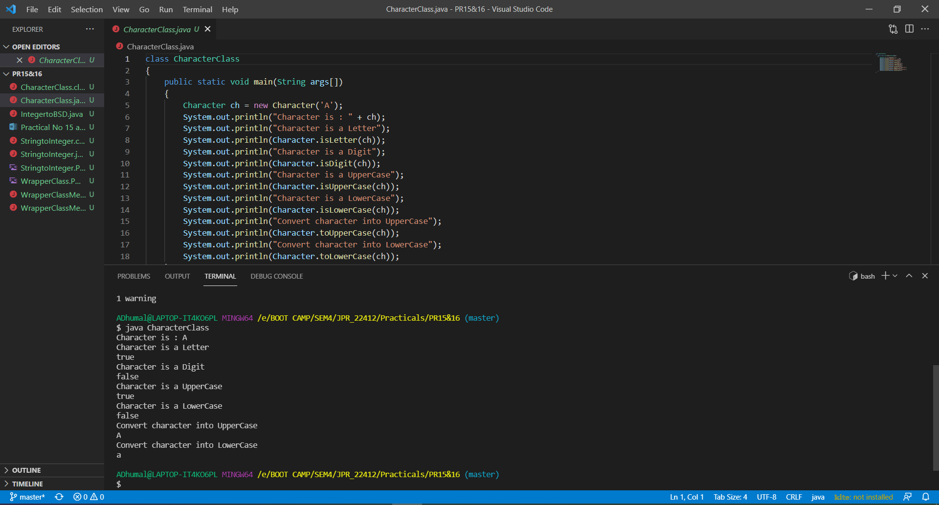

1. **Write a program to convert Integer object value into primitive data type byte, short, and double value.**

